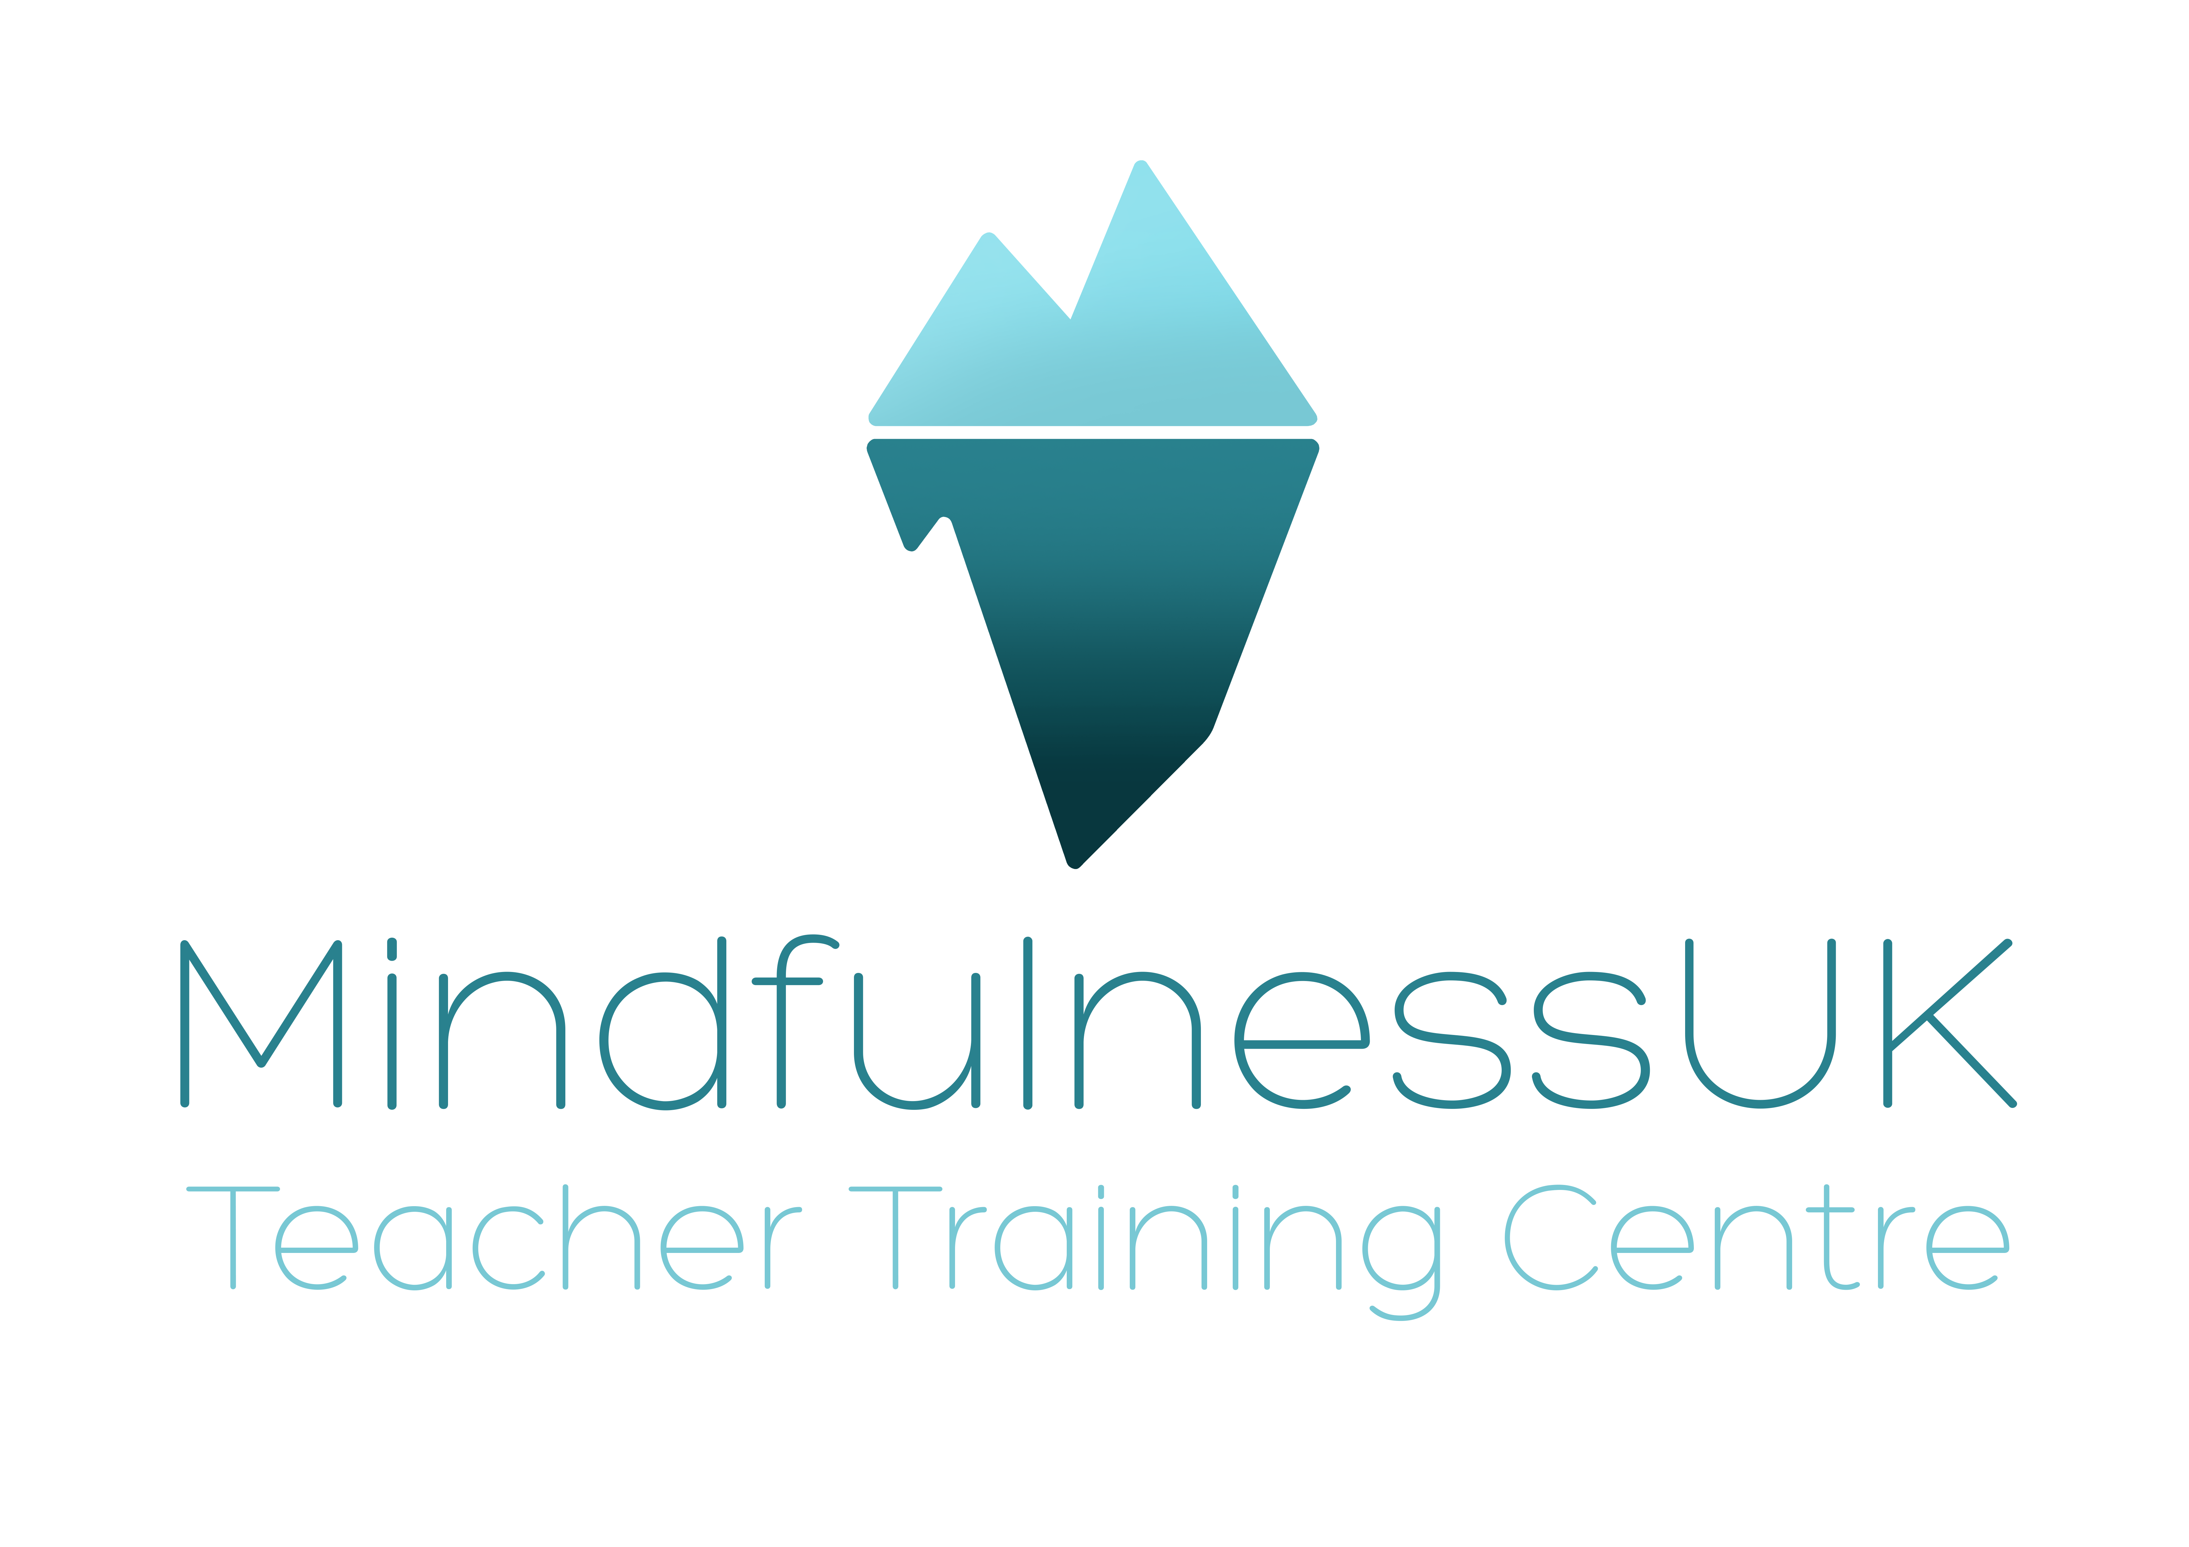
Mindfulness-based Stress Reduction Initial Assessment Form
Thank you for filling out this form. We realise the personal nature of these questions and please be assured that they are kept in strict confidence adhering to the GDPR 2018. The data will be kept for the duration of the course. On completion of the course you may request that the information be returned to you or disposed of from our records.
Name:
Contact Email:
Telephone:
Course dates you are intending to attend:

Questions
- Do you know anything about Mindfulness, please give details?

- What is your main reason for wishing to participate in this Course?

- Although this is not a therapy group it is helpful to know if there any significant personal issues going on in your life.

- If you become upset during sessions, as the teacher I encourage my students to create some space, switch off their camera and use their breath as an anchor to focus attention. How else would you like to be supported?

- Between sessions there is an expectation that you do guided home practices for 30 minutes per day plus additional short exercises and strategies.
- Do you have time to do this?
Yes/ No

- When and where would that be?

- Do you have any difficulties that we can help you with such as pain, mobility, props to make you more comfortable? Supportive chair required? Yes/ No

- Please can you describe your relationship with alcohol and recreational drugs. We ask this question in order to support you the best we can in our teaching and to ensure that a Mindfulness programme is right for you at this time.

- Do you have any questions of any sort or is there anything else we can help you with to support your attendance on the Course?

When you have completed the form please return it to stephanie.unthank@mindfulnessuk.com. I will then contact you directly prior to Course commencement via telephone and ask or answer any more specific, personal questions, if required.

