
Retreat assessment form (Sharpham House)
Please complete & return to info@mindfulnessuk.com
NAME: |  | Date
EMAIL: |  |  | Date of Birth
ADDRESS:
OCCUPATION:
Doctor’s details

How did you find out about the MindfulnessUK Retreat?

Main reason for attending the retreat
What are your intentions and expectations of the retreat?

Have you been hospitalized in the last year for any reason? Details.
Are you on any prescribed medication?
Do you take any recreational drugs? Details

Do you have any physical, psychological, emotional, lifestyle or attitudinal issues?
(Suicidality if appropriate)
Have you suffered with any trauma or significant difficulties that would be helpful for the teacher to know about? Details

Are you suffering from any of the following conditions:
- Panic attacks  - Low blood pressure | - IBS  - Back, neck or knee pain

Sleep patterns:
Allergies/ sensitivities:

Treatments from other health professionals in the last 3 years
Do you have any difficulties that we need to know about so we can support you in your experience of the retreat?

Hard of hearing,
Require a chair

Past Retreats/meditation/ mindfulness experience:
- what
- where
- how long
- response and support

Past yoga or other mindful movement practice:
- type
- when
- response
The next section is only to be completed if the retreatant suffers with pain
If you suffer with pain which words that best describe your experiences:  Throbbing Shooting Stabbing  Heavy Tender Sharp  Cramping Gnawing Hot/burning  Aching Splitting Tiring/exhausting  Sickening Fearful Punishing/cruel  Other: | 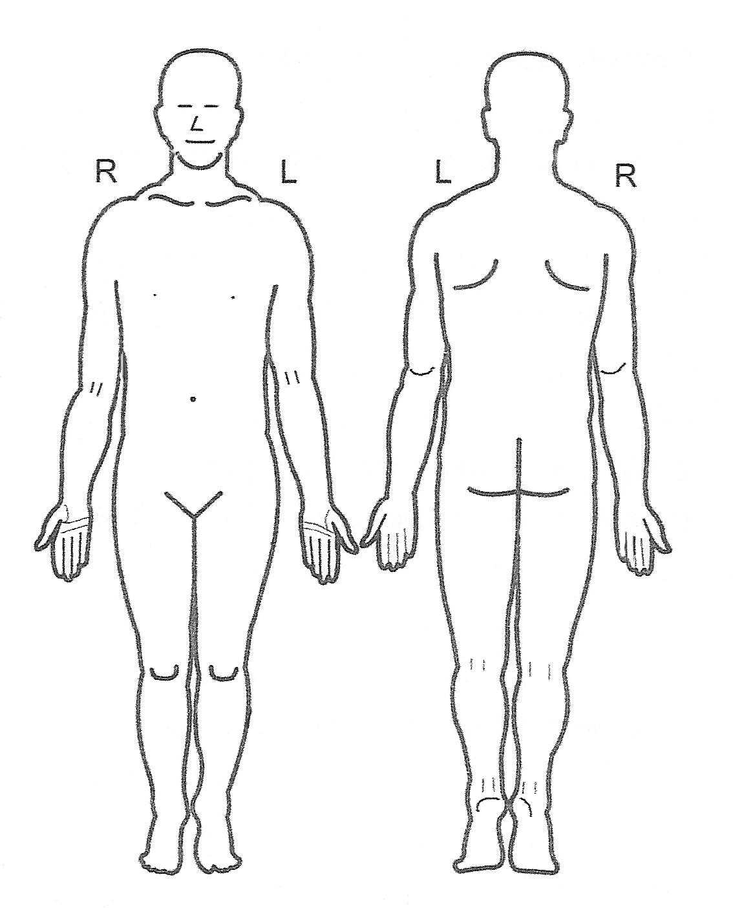

When is pain worst | Morning Afternoon Evening Night
How much does pain interfere with sleep?
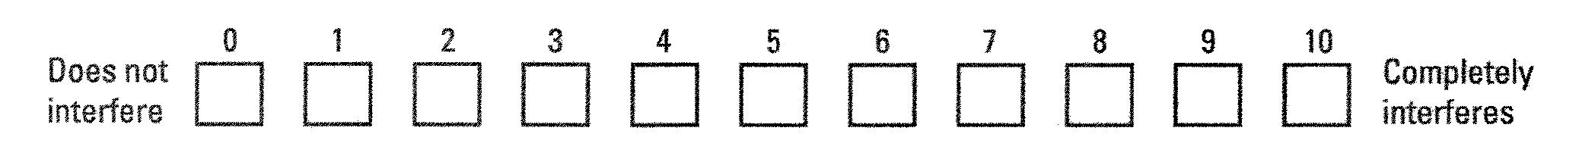

Three things that make the pain better and three that make it worse
Better | Worse

Is there anything else we can do for you to support your learning? Please use the space below if you want to let us know anything:

Consent
Everything you share with me is strictly confidential and will only be shared with another professional if you or someone else is at risk.
All information is stored and destroyed in adherence with GDPR regulations.
All the information I (client) have provided is true on the date given.
Date:
Signed by client:

